**Performing test automation for the specifications below using Selenium**

**Strategy:**

**Framework to be used**

* POM (Page Object Model)
* TestNg with POM and XML.
* Modular concept framework.
* Data driven concept – Using TestNG or Excel

**Other strategy:**

* Multibrowser execution
* Coding standards to be followed
* Screen shots to be taken

**Case Study 1: Functional testing using Selenium**

**Notes:**

* Make sure Test environment is up and running
* Perform Smoke and Exploratory testing to Know more about the application

**Case Study for Automation Project**

**Read the below instructions before you take up the assessment:**

A web-based scenario of **medium** complexity would be provided. Associate should utilize automation testing project on THE JPET STORE

**Points to be noted during your project:**

* Followed POM (Page Object Model) standards and organizing pages/java class files
* Implemented TestNg with POM. Proper TestNG concepts and XML to run the project.
* Should have implemented reusable functions separately to improve more readability.
* Multi browser execution- Should have handled at least two browsers (Firefox and IE/Chrome). Optional - desired capabilities/driver setup
* Data driven concept - Input data should be imported from an external excel sheet (Ex: using Apache PoI libraries in case of Java) or Properties file or flat file
* Handled exceptions with exception handling & error messages
* Should have used relative Xpath
* Check code is syntactically correct and executes end to end successfully
* Coding standard should be followed, which includes variable, object naming convention, script headers & comments
* Used ID or Name locator instead of XPATH
* Functions should have header, comments wherever applicable to improve readability and maintainability
* Should handle page synchronization issues using industry standard best practices. Use Timeout instead of Sleep statement wherever applicable.
* Validation messages should be logged into the Test Results with screenshot. Log mandatory test-steps in reporting statement

**Read the requirement carefully and submit Test Automation Solution as mentioned below:**

**Note:**

* Before you start automating the case study, execute the given test case scenario manually to understand the application flow better.
* Implement the code using TestNg/Junit with POM(Page Object Model). Proper TestNG/Junit concepts and XML to run the project with specific Folder structure and Class files.
* Implement code for at least 2 Browsers by handling exceptions & error messages.

**Case Study Name:** THE Pet Store

**Website** <https://jpetstore.cfapps.io/>

**Steps to be followed:**

1. Navigate to <https://jpetstore.cfapps.io/catalog> Searching for a Product
2. Registering a new user account

* Enter User ID
* Enter New Password
* Enter Repeat Password
* Enter First Name
* Enter Last Name
* Enter Email
* Enter Phone
* Enter Address1
* Enter Address2
* Enter City
* Enter State
* Enter Zip
* Enter Country
* Select Language Preference
* Select Favorite category
* Click Enable my list if necessary
* Click Enable my banner if necessary
* Click Save Account Information Button

NOTE: Retrieve the required data from Excel sheet

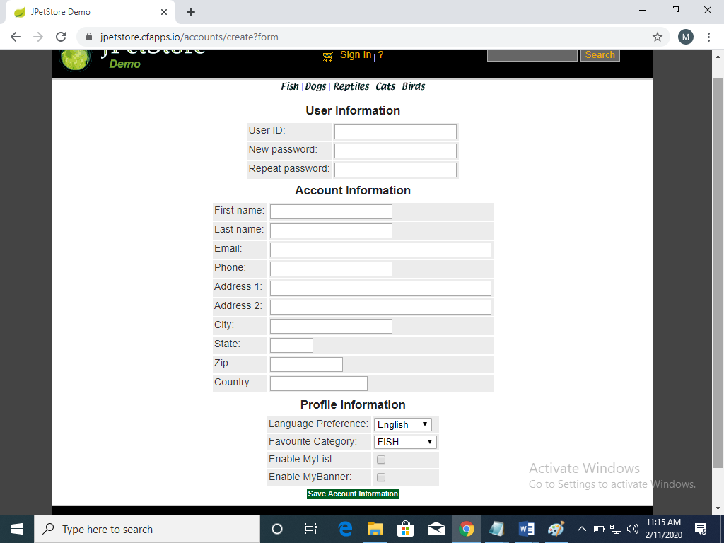

1. Login to user account

* Enter Username
* Enter Password
* Click Submit

NOTE: Retrieve the required data from properties file

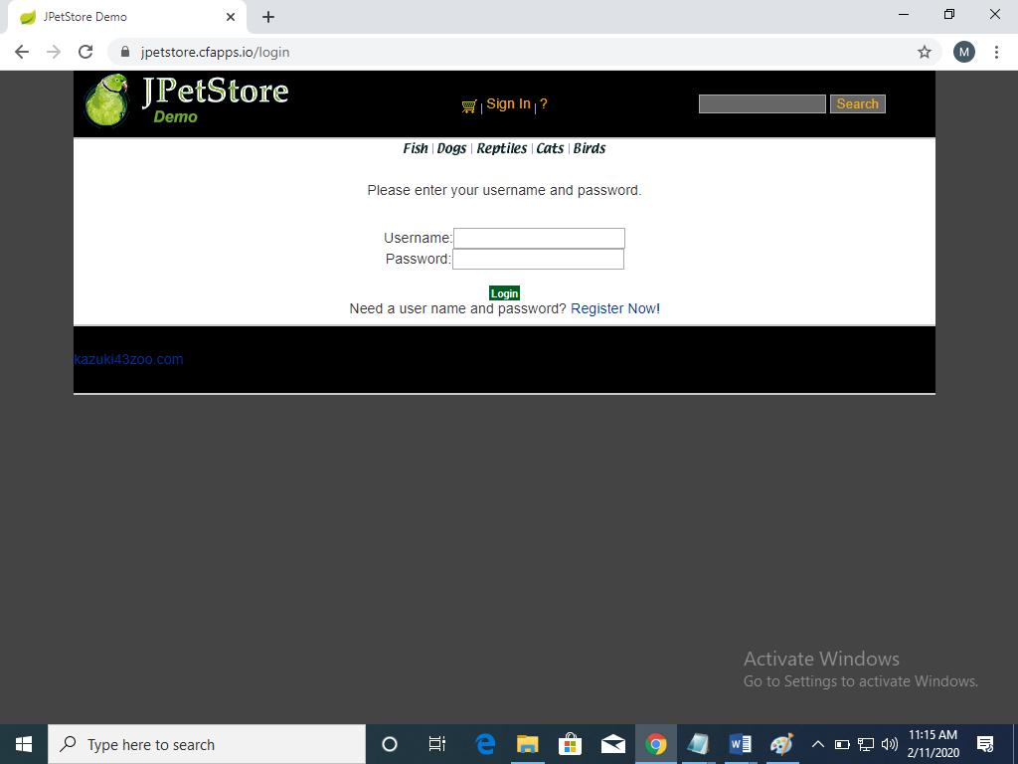

1. Select a product and add item to cart

* Select the required product from the given menu

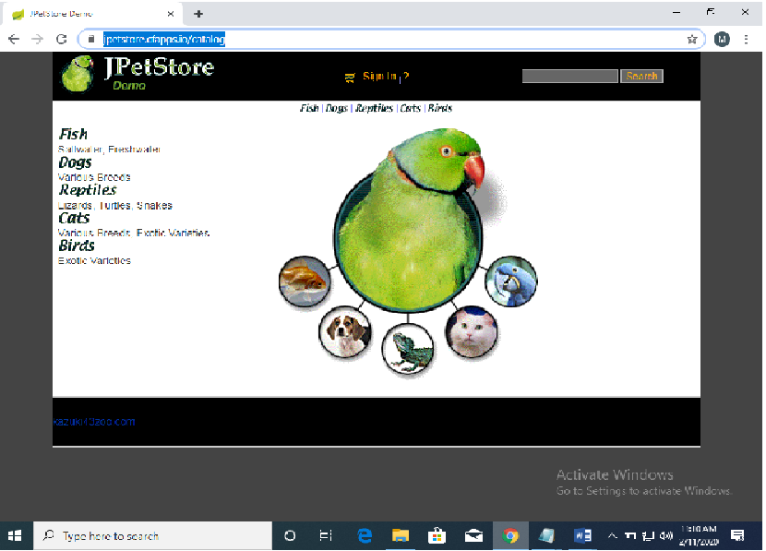

* Select the product ID of the required product

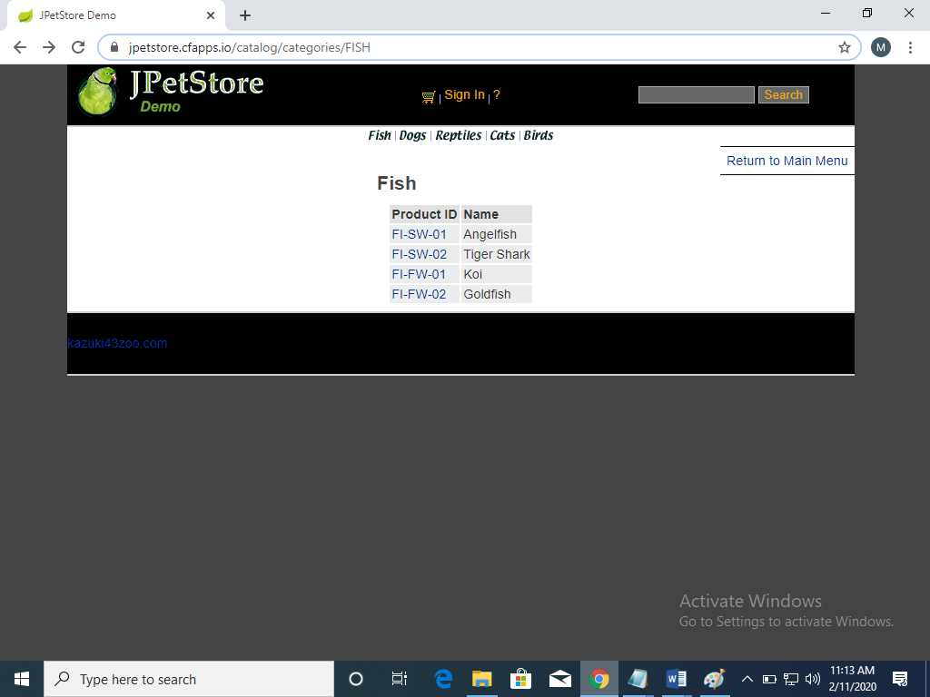

* Add the item to cart by click on the option “Add to cart”

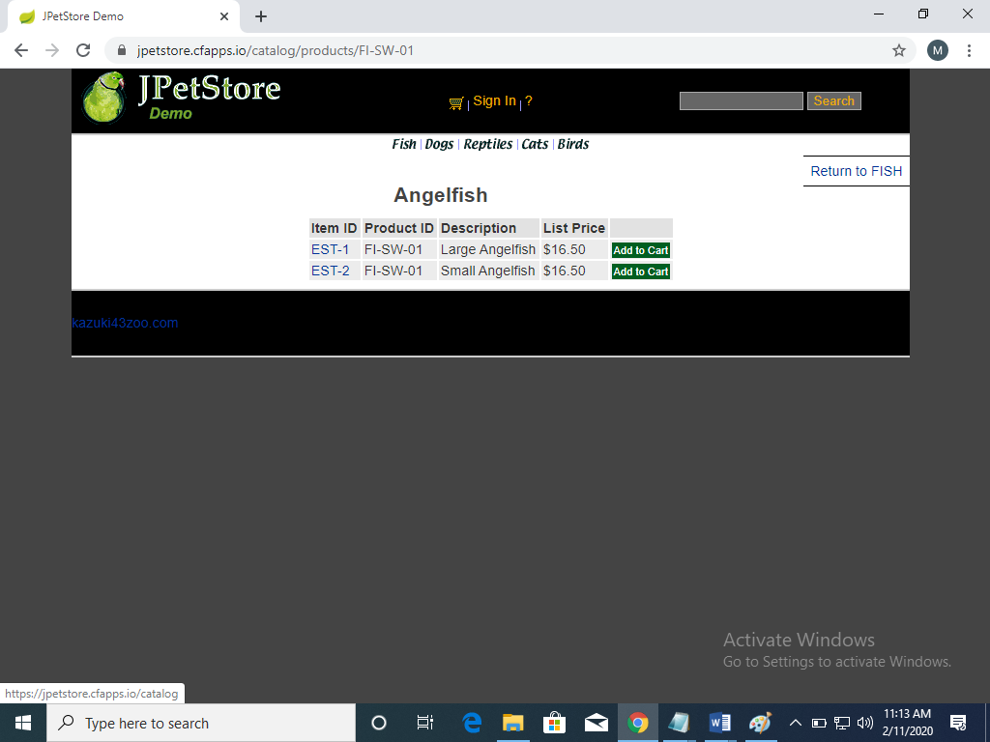

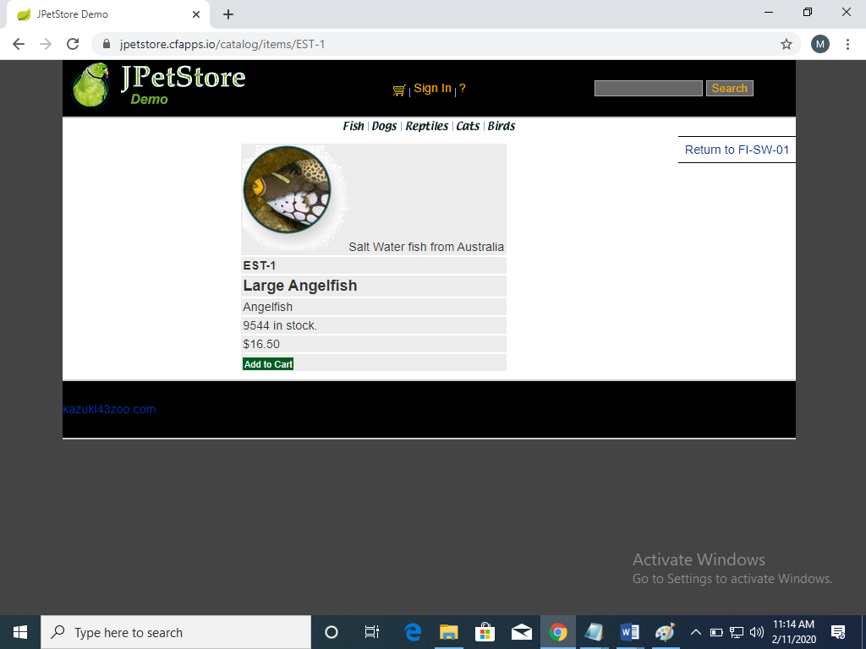

1. Purchasing an item by placing an order as a registered user by giving payment details and shipping address and press submit button.
2. Finally Logout from the Application.

Deliverables:

* Create new folder in your system and save the all file in the folder.